Clinical Trial Drug Supply Chain Simulation System - Business Specification
1. System Overview
1.1 Business Objective
Simulate the drug supply chain for a 2-year international multi-center clinical trial, ensuring 250 patients receive continuous medication throughout a 52-week treatment period while minimizing waste and stockout risks.
1.2 Trial Basic Information
- Trial Type: Randomized, double-blind, placebo-controlled, parallel-group design
- Treatment Arms: Active drug (ACT) vs Placebo (PBO), ratio 1:1
- Total Patients: 250 (EU region: 100, China region: 150)
- Number of Sites: 23 (EU: 13 sites, China: 10 sites)
- Treatment Duration: 52 weeks
- Recruitment Duration: 450 days (approximately 15 months)
2. Supply Chain Network Structure
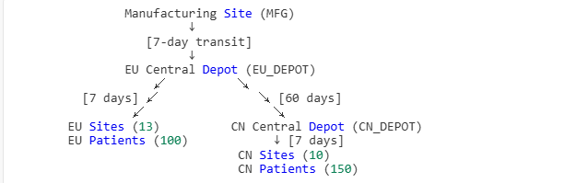
Key Features
- Unidirectional Flow: All drugs must first arrive at EU depot before transfer to China depot
- Three-tier Inventory: Central depot → Regional depot → Sites
- Double-blind Management: Drugs labeled as A/B, actual correspondence to ACT/PBO is confidential
3. Patient Recruitment and Stratification
3.1 Recruitment Model
Site-tiered Recruitment Rates (patients enrolled per month):
- Low-tier sites: 1 patient/month
- Medium-tier sites: 2 patients/month
- High-tier sites: 4 patients/month
Each region has 1/3 of sites in each tier.
Screen Failure Rate: 35% (i.e., need to screen 385 patients to enroll 250)
Inactive Sites: 15% of sites will not recruit any patients
3.2 Stratification Factors
Patients are stratified and randomized by:
- Region: EU vs China
- Body Weight: <90kg vs ≥90kg
  - EU region: 70% of patients <90kg
  - China region: 80% of patients <90kg
3.3 Randomization Method
Stratified Block Randomization:
- Each stratum (region × body weight combination) generates independent random blocks
- Block size: randomly selected as 4 or 6
- Within each block, equal numbers of A/B, random order
4. Dosing Regimen and Visit Schedule
4.1 Visit Schedule
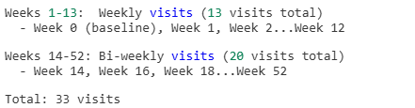
- Unscheduled rate:10%
- Missing visit rate :10%
4.2 Dosing Rules
Weeks 1-13 (Weekly Visit Period)
Body Weight | Dispensed per Visit
<90kg | 3 × 5ml kits
≥90kg | 5 × 5ml kits
Weeks 14-52 (Bi-weekly Visit Period)
Body Weight | Dispensed per Visit
<90kg | 1 × 2.5ml kit
≥90kg | 1 × 7.5ml kit
4.3 Dosing Example
Patient A (weight 85kg, assigned to Group A):
- Weeks 0-12: Receive 3 × 5ml-A kits weekly, 13 visits = 39 kits
- Weeks 14-52: Receive 1 × 2.5ml-A kit bi-weekly, 20 visits = 20 kits
- Total: 59 kits
Patient B (weight 95kg, assigned to Group B):
- Weeks 0-12: Receive 5 × 5ml-B kits weekly, 13 visits = 65 kits
- Weeks 14-52: Receive 1 × 7.5ml-B kit bi-weekly, 20 visits = 20 kits
- Total: 85 kits

5. Drug Shelf Life Management
5.1 Shelf Life Rules
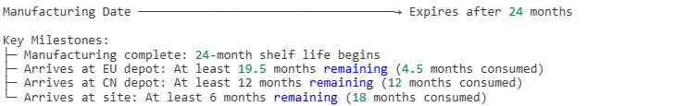
5.2 Dispensing Restrictions (DND Rule)
Do Not Dispense (DND) = 13 days
When dispensing drugs at sites, must ensure:
Drug expiry date > Today + 13 days
i.e., Cannot dispense drugs expiring within 13 days.
5.3 First Expired, First Out (FEFO)
When dispensing drugs at sites, prioritize using kits with earliest expiry dates.

6. Inventory Replenishment Rules
6.1 Site Replenishment Trigger Conditions
Dual-threshold System (for each "kit_type__arm" combination):
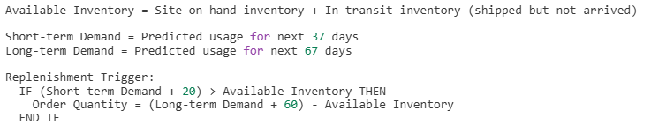Parameter Explanation:
- Minimum inventory threshold: 20 kits
- Target inventory threshold: 60 kits
- Short-term window: 7-day transit + 30-day buffer = 37 days
- Long-term window: 37 days + 30-day additional buffer = 67 days
6.2 Demand Forecasting Method
Based on enrolled patients' visit schedules:
For each patient, calculate the "earliest possible date" for future visits:
Earliest Visit Date = Enrollment Date + Planned Visit Day - Visit Window (4 days)
If the earliest visit date falls within the forecast window, include that patient's drug demand.
Example:
- Patient C enrolled on Day 10
- 3rd visit planned 14 days after enrollment (i.e., Day 24)
- Earliest possible visit date = 10 + 14 - 4 = Day 20
- If today is Day 15, forecast window is next 37 days (Days 15+37=52)
- Day 20 is within window → Include Patient C's 3rd visit drug demand
6.3 Pre-positioning for Future Enrollments
Enabled only when global recruitment is incomplete
Based on site's monthly recruitment forecast, pre-stock drugs:
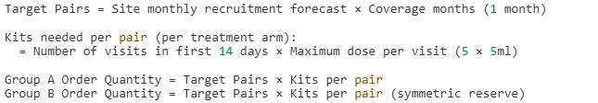
Purpose: Ensure sufficient drugs available when new patients enroll.
6.4 Emergency Replenishment
Daily check: If demand for next 14 days exceeds available inventory, ship immediately.

7. Inter-depot Transfer Rules
7.1 EU → CN Automatic Transfer
Trigger Timing: Each time a manufacturing batch arrives at EU depot
Transfer Proportion: 50% of received quantity
Protection Mechanism:
- Reserve EU region's predicted demand for next 90 days
- Additional reserve of 7.5ml kits for regional safety stock (prevent stockouts when patients transition from weekly to bi-weekly phase)
7.2 CN Depot Target Coverage Replenishment
Check Frequency: Daily
Logic:
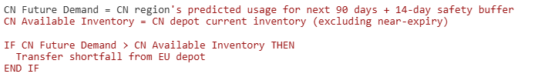
8. Manufacturing Plan
8.1 Planned Manufacturing
8 batches, produced every 60 days:
- Day 0, Day 60, Day 120...Day 420
Quantity per batch:
Daily consumption × (150-day coverage + 60-day safety stock) = 210 days' supply
8.2 Additional Manufacturing (Triggered as needed)
Check Condition (after 60-day cooldown):
EU depot available inventory < Predicted demand for next 150 days
AND Shortage ratio ≥ 1%
Then trigger additional manufacturing to fill the gap.
9. Shipment Damage and Expiry
9.1 Shipment Damage
Damage Rate: 1%
Upon each shipment arrival, randomly damage 1% of kits; damaged kits are not added to inventory.
9.2 Expiry Handling
Daily check: Zero out quantity of expired drugs (expiry date < today), record to expiry log.
10. Blinding Management
10.1 Drug Labels
- Drugs labeled as A or B (blind codes)
- Actual correspondence: A=ACT (active drug), B=PBO (placebo)
- Patients, investigators, and supply chain personnel do not know the true meaning of A/B
10.2 Inventory Balancing (Deprecated)
Old version enforced 1:1 A/B inventory balance at sites; current version removed this, now orders based on actual demand.
11. Key Performance Indicators (KPIs)
11.1 Site Level
- Stockout Days: Days when site cannot meet patient drug needs
- Stockout Kits: Cumulative number of kits short
- Average Inventory: Daily average on-hand inventory (DNC perspective)
- Average In-transit Inventory: Daily average in-transit inventory
- Expired Kits: Total kits expired at site
- Order Count: Number of routine orders, emergency orders
11.2 Depot Level
- Total Received: Initial inventory + shipment receipts
- Total Shipped: Total shipped to sites or other depots
- Shipment Damage: Kits damaged during transit
- Expired Quantity: Kits expired at depot
- Final Inventory: Remaining inventory at simulation end
- Waste Rate: (Damage + Expiry) / Total Received
11.3 Patient Level
- Total Drug Usage: Total kits actually received per patient
- Stockout Occurrences: Number of times patient encountered stockout during visits
12. Business Scenario Examples
Scenario 1: Patient First Visit
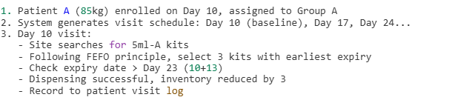
Scenario 2: Site Triggers Replenishment
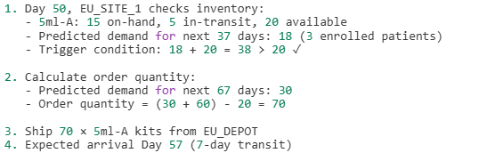
Scenario 3: Drug Expiry
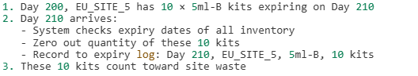
Scenario 4: Manufacturing Batch Arrival and Auto-transfer
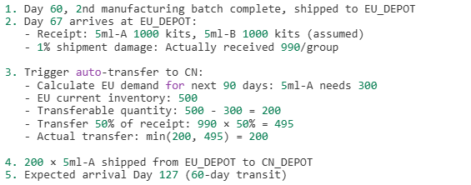
13. System Outputs
13.1 Main Reports
- Patient Visit Detail Table: Drug usage record for each patient at each visit
- Site KPI Summary Table: Stockout, inventory, and order statistics per site
- Site Daily Inventory Table: Daily inventory changes for each kit type at each site
- Depot Waste Analysis Table: Receipt/shipment/inventory and waste for EU/CN depots
- Shipment Record Table: Detailed information for all shipment batches
- Site Enrollment Summary Table: Recruitment rate and enrollment count per site
13.2 Key Decision Support
- Manufacturing Plan Optimization: Whether to increase/decrease manufacturing batches
- Inventory Threshold Adjustment: Whether min/max inventory settings are reasonable
- Transfer Strategy Evaluation: Whether EU→CN transfer proportion is appropriate
- Site Risk Identification: Which sites have high stockout risk
14. System Assumptions and Limitations
14.1 Assumptions
- All sites start simultaneously (actual may be phased)
- Patient visits strictly follow schedule (actual has window period variation)
- Transit times are fixed (actual may have delays)
- Drug quality is stable (no recalls considered)
14.2 Limitations
- Does not support patient cross-site transfers
- Does not support mid-study dose regimen changes
- Does not support lateral transfers between depots (only EU→CN unidirectional)
- Does not consider drug cost differences
15. Success Criteria
15.1 Supply Continuity
- Stockout Rate < 5%: Proportion of site stockout events to total visits
- Zero Patient Stockouts: Ideally, all patients receive drugs at all visits
15.2 Inventory Efficiency
- Waste Rate < 15%: (Expiry + Damage) / Total Production
- Turnover Rate: Average inventory days < 90 days
15.3 Cost Control
- Manufacturing Batches: Minimize additional manufacturing batches
- Shipment Frequency: Optimize shipment frequency and batch size

